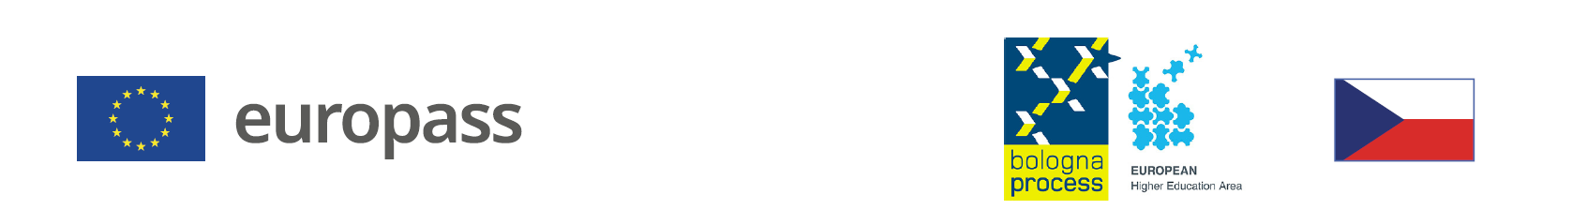 |  | EUROPASS DIPLOMA SUPPLEMENT  OF THE TERTIARY PROFESSIONAL SCHOOL GRADUATE    NAME AND ADDRESS OF THE TERTIARY  PROFESSIONAL SCHOOL (VOŠ)
1. INFORMATION IDENTIFYING THE HOLDER OF THE QUALIFICATION
 |  | Last name/s |  |  |  |  |  |  | First name/s
1.1 |  |  |  |  |  |  |  | 1.2
 |  | Date of birth (dd/mm/yyyy) |  |  |  |  |  |  | Student identification number / code (if available)
1.3 |  |  |  |  |  |  |  | 1.4
2. INFORMATION IDENTIFYING THE QUALIFICATION
 |  | Awarded degree and conferred title (if applicable) |  |  |  |  |  |  | Main field/s of study for the qualification
2.1 |  |  |  |  |  |  |  | 2.2
 |  | Name and status of awarding institution  (in original language) |  |  |  |  |  |  | Name of institution providing the study course  (if different from 2.3, in original language)
2.3 |  |  |  |  |  |  |  | 2.4
 |  | Language/s of instruction and examination
2.5
3. INFORMATION ON THE LEVEL OF THE QUALIFICATION
 |  | Level of education |  |  |  |  |  |  | Official length of programme
3.1 |  | ISCED 655, EQF 6 |  |  |  |  |  | 3.2
 |  | Access requirements
3.3 |  | Upper secondary education completed by the Maturita examination ISCED 344 and ISCED 354, EQF 4, entrance examination
4. INFORMATION ON THE CONTENTS AND RESULTS GAINED
 |  | Mode of study
4.1
 |  | Programme requirements
4.2
 |  |  | Programme details and the individual grades / credits obtained
 | 4.3 |  | Module / subject code |  |  | Module / subject title |  |  |  | Required  assessment | Grade | Date | Number of  ECTS credits
 | Records of professional training and experience
 | Professional training and experience | Number of hours | Note

 | Absolutorium | Grade | Date
 | Foreign language
 | Vocational subjects
 | Graduate thesis topic
 | Graduate thesis defence

 | Overall assessment | Date
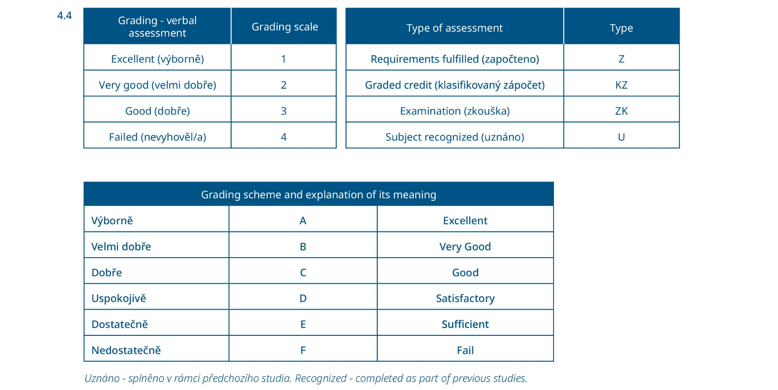
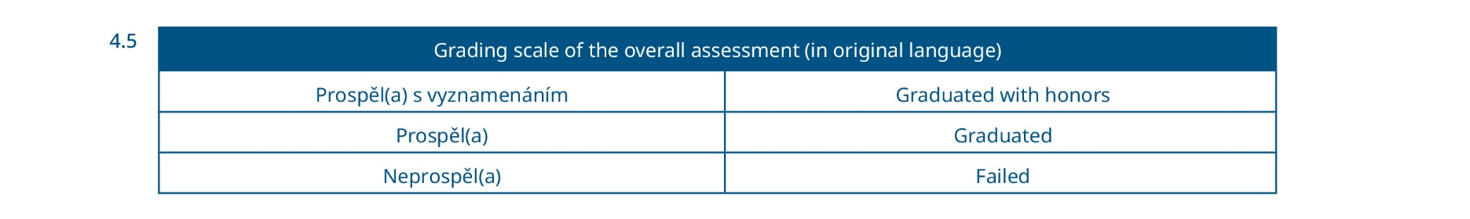

5. INFORMATION ON THE FUNCTION OF THE QUALIFICATION
 | Access to further study
5.1 | Bachelor‘s studies ISCED 645, EQF 6  Master‘s studies ISCED 746, EQF 7
 | Examples of occupations accessible to the diploma holder
5.2
6. ADDITIONAL INFORMATION
 | Additional information
6.1
 | Further information sources
6.2
7. CERTIFICATION OF THE SUPPLEMENT
 | Date |  |  |  |  | Official stamp
7.1 |  |  |  |  | 7.4
 | Name and signature
7.2
 | Capacity
7.3

Diploma Supplement follows the model developed by the European Commission, Council of Europe and UNESCO/CEPES. The purpose of the supplement is to provide sufficient independent data to improve the international ‘transparency’ and fair academic and professional recognition of qualifications (diplomas, degrees, certificates etc.). It is designed to provide a description of the nature, level, context, content, and status of the studies that were pursued and successfully completed by the individual named on the original qualification to which this supplement is appended. It should be free from any value judgements, equivalence statements or suggestions about recognition.
https://europass.cz/
https://europass.europa.eu/en

© European Union, 2005–2026

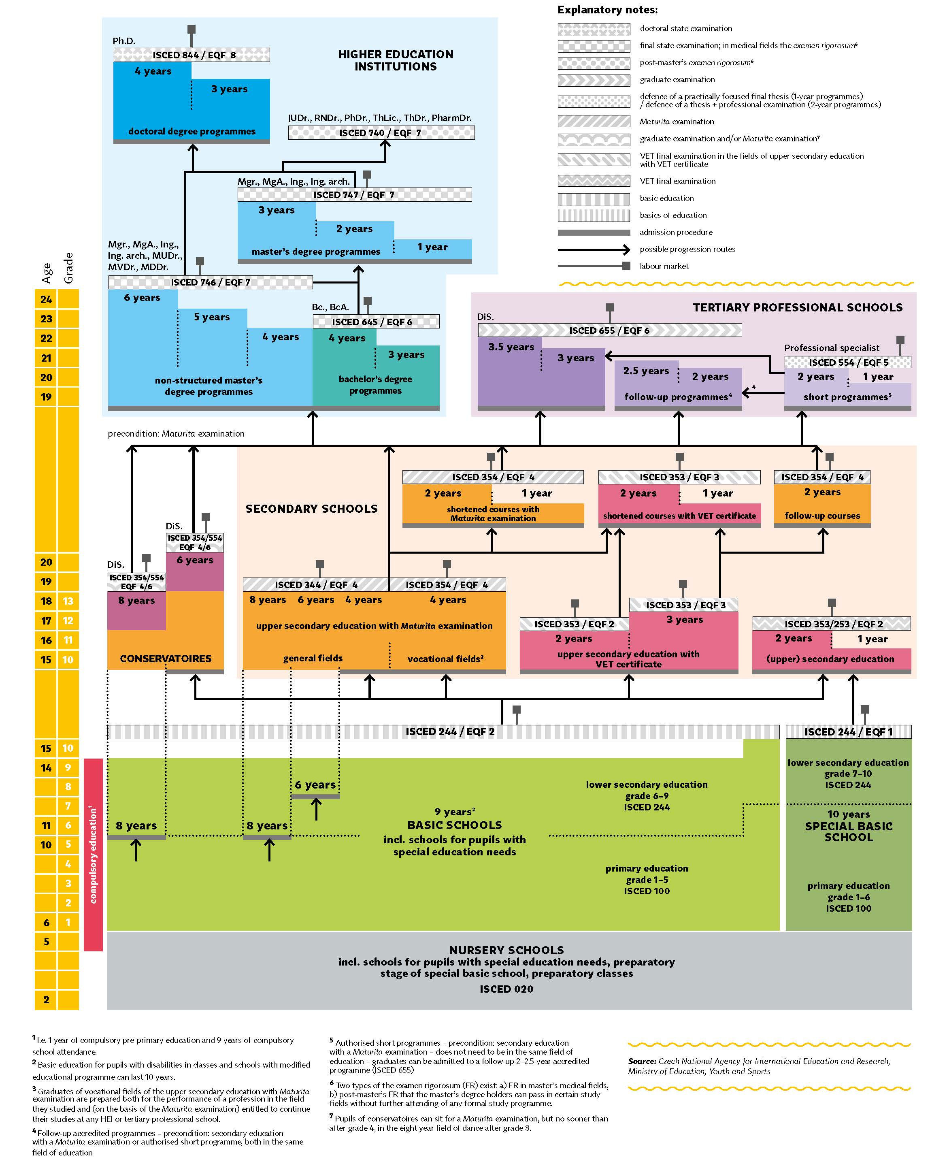
8. DIAGRAM OF THE EDUCATION SYSTEM OF CZECHIA 2026

