

Europass Diploma Supplement
CZECH REPUBLIC
of the Tertiary Professional School Graduate

NÁZEV A ADRESA VOŠ
LOGO VOŠ (nepovinné)

 | 1. Information identifying the holder of the qualification
 | Last name/s |  |  |  |  | First name/s
1.1 |  |  |  |  | 1.2
 | Date of birth (dd/mm/yyyy) |  |  |  |  | Student identification number / code (if available)
1.3 |  |  |  |  | 1.4
 | 2. Information identifying the qualification
 | Awarded degree and conferred title (if applicable) |  |  |  |  | Main field/s of study for the qualification
2.1 |  |  |  |  | 2.2
 | Name and status of awarding institution (in original language) |  |  |  |  | Name of institution providing the study course(if different from 2.3, in original language)
2.3 |  |  |  |  | 2.4
 | Language/s of instruction and examination
2.5
 | - Information on the level of the qualification
 | Level of education |  |  |  |  | Official length of programme
3.1 | ISCED-A 650, EQF 6 |  |  |  | 3.2
 | Access requirements
3.3 | Completed upper secondary education completed by the Maturita examination ISCED-A 344, ISCED-A 354, EQF 4, entrance examination
 | - Information on the contents and results gained
 | Mode of study
4.1
 | Programme requirements
4.2

 | Programme details and the individual grades / credits obtained
4.3 | Module / subject code | Module / subject title | Required  assessment | Grade | Date | Number of  ECTS credits

 | Records of professional training and experience  Professional training and experience | Number of hours | Note

 | Absolutorium | Grade | Date
 | Foreign language
 | Vocational subjects
 | Graduate thesis topic
 | Graduate thesis defence
 | Overall assessment |  | Date

 | Grading scheme and explanation of its meaning
4.4
 | Grading scale of the overall assessment (in original language)
4.5
 | - Information on the function of the qualification
 | Access to further study
5.1 | Bachelor´s studies ISCED-P 645, EQF 6  Master´s studies ISCED-P 746, EQF 7
 | Examples of occupations accessible to the diploma holder
5.2
 | - Additional information
 | Additional information
6.1
 | Further information sources
6.2
 | - Certification of the supplement
 | Date |  |  |  |  | Official stamp
7.1 |  |  |  |  | 7.4
 | Name and signature
7.2
 | Capacity
7.3

Explanation:
This document is called the Diploma Supplement of the Tertiary Professional School Graduate. It is only valid together with an absolutory report and provides additional information on educational content in the given type of tertiary courses and it is not a legal document itself. The diploma supplement is based on the Decision No 2241/2004/EC of the European Parliament and of the Council of 15 December 2004.

For more information:
http://europass.cedefop.europa.eu
www.europass.cz

8. Information of the tertiary education in the czech republic
Tertiary education in the Czech Republic
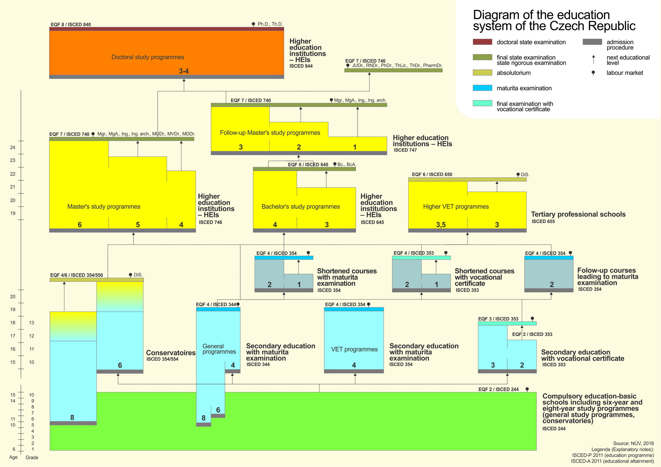

The newest segment in the education system of the Czech Republic, tertiary professional schools (VOŠ), provide education on ISCED-A 650 level and are included in level 6 within EQF (European Qualification Framework). They mostly constitute one legal entity together with vocational secondary schools and are devided according to the educational authority into public, private and church ones. Two of them have a status of higher education institutions. Tertiary professional education develops and deepens knowledge and skills of the students acquired in secondary education with school-leaving examination and provides general and professional education for carrying out demanding professional activities requiring experience. In some of the fields, the practical preparation takes 14-16 weeks during study at the most (at the workplace/practical training at school). The education programme must obtain accreditation which is granted by Accreditation Commission for tertiary professional education. The Ministry of Education, Youth and Sports decides afterwards whether the VOŠ is included in the school register. The length of tertiary professional education in full-time study form is 3 years. The education can also take other forms (part-time, evening courses, distant and combined) which can be one year longer at the most. The study at VOŠ is concluded by „absolutorium“ (graduation examination) consisting of three parts (foreign language examination, examination in up to three vocational subjects and defence of a written assignment. The document certifying achievement of the education is the absolutorium report and the diploma. VOŠ graduates are awarded a degree “diplomovaný specialista” (a qualified specialist) which is stated after their name as “DiS”.

Conservatories are a specific type of secondary education and tertiary professional schools with a different operating mode. Students talented for performing arts must take a talent examination as a part of the admission procedure. Students who completed grade 9 of basic school can be admitted in six-year music and dramatic art courses. Students who completed grade 5 of basic school can be admitted in an eight-year dance course. These students complete their compulsory school attendance in lower grades of the conservatories. Conservatory students can take an optional Maturita examination (ISCED-A 354, EQF 4) but only after completing grade 4 of the conservatory (grade 8 of the dance course). Six-year and eight-year education are generally completed by the absolutorium. The document certifying achievement of this type of education is the absolutorium report and the diploma. Conservatory graduates are awarded a degree “diplomovaný specialista” (a qualified specialist) which is stated after their name as “DiS” (ISCED-A 650, EQF 6).

Higher education institutions provide accredited study programmes and programmes of lifelong learning. A bachelor’s degree programme focuses on job preparation. Bachelor’s study takes 3-4 years (ISCED-A 640, EQF 6). Graduates can continue their study in Master’s degree programmes. A master’s degree programme focuses on gaining both theoretical and practical knowledge based on the current state of scientific knowledge, research and development, on applying it in practice and on developing skills in creativity; in the field of arts they aim at demanding arts training and talent development. A master’s degree programme follows a bachelor’s degree programme. The standard length of study is 1-3 years (ISCED-A 740, EQF 7). In cases where the nature of a study programme so requires, a master‘s degree programme can be accredited without a previous bachelor’s degree programme; in those cases it lasts 4-6 years (ISCED-A 740, EQF 7). A completed master’s degree programme can be followed, in case of interest or need, by a doctoral degree programme. It focuses on scientific research and independent creative activity in the field of development or the independent theoretical and creative activity in the field of art. The standard length of study is 3-4 years (ISCED-A 840, EQF 8).

